SHOW ALL WORK on the worksheet

Write the equation of each function

1. 2. 3.

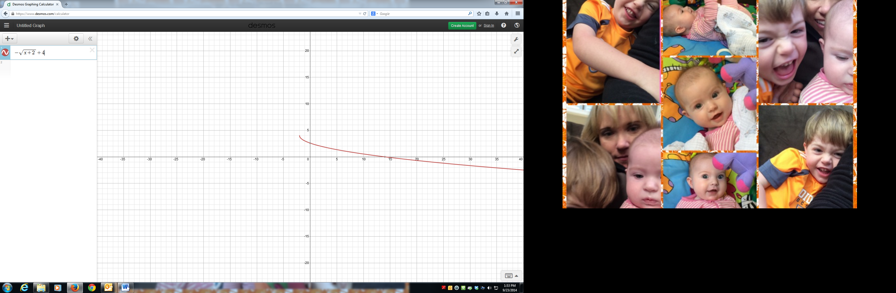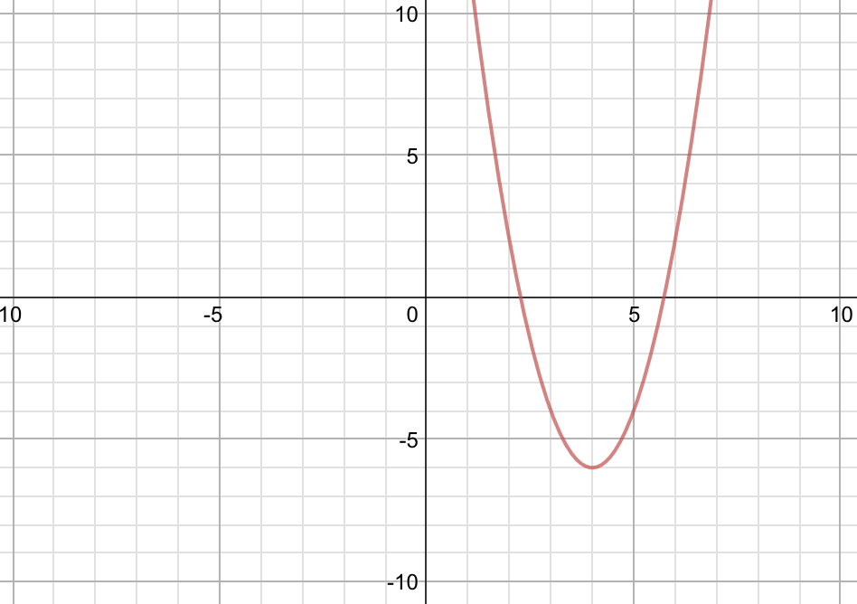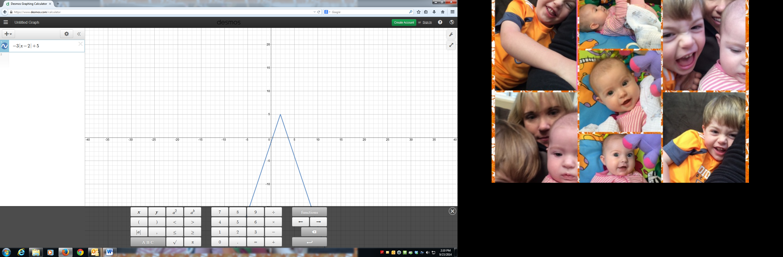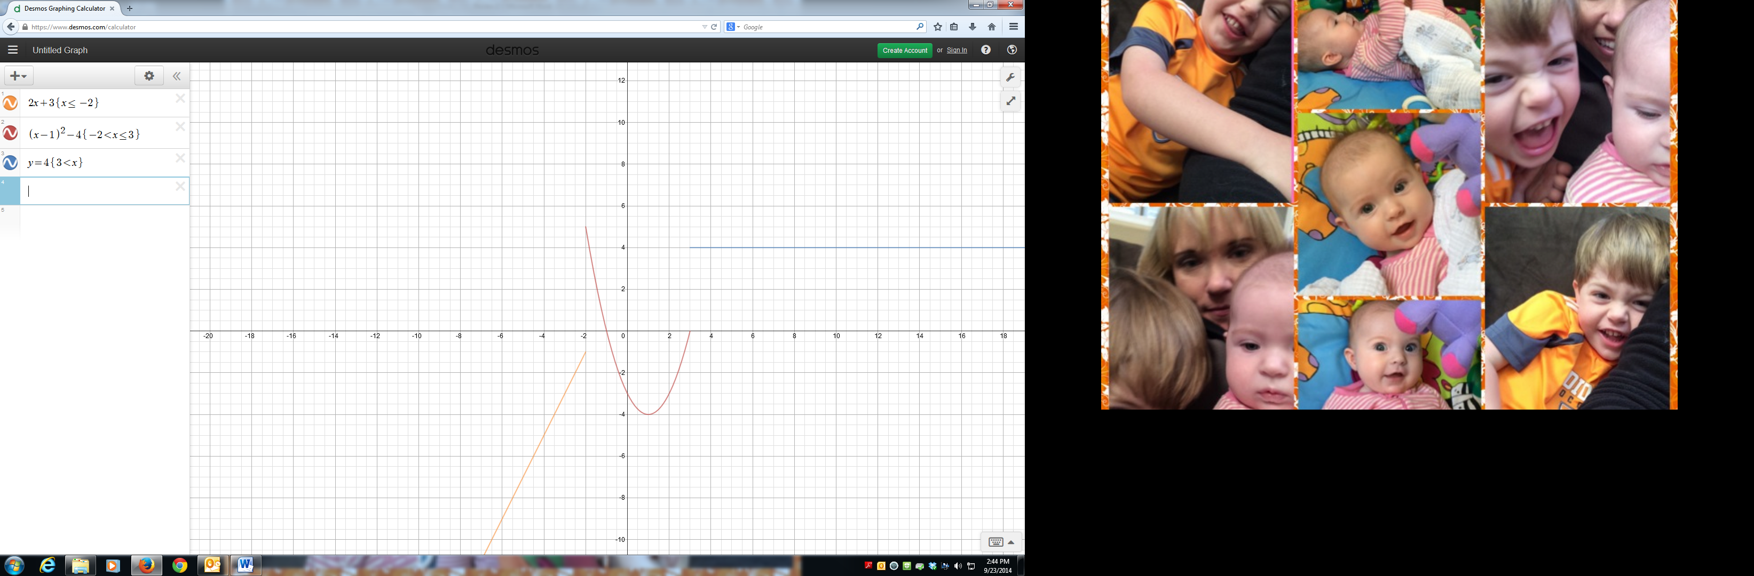

4. 5.

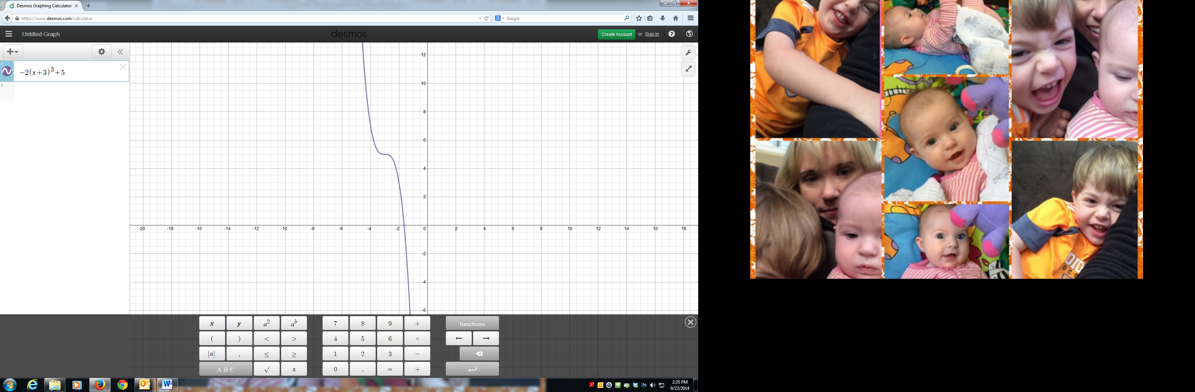

Graph each function

6. 7.

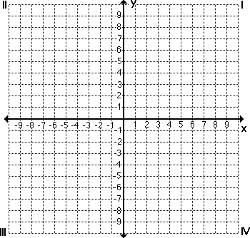

Determine if each function is even, odd, or neither

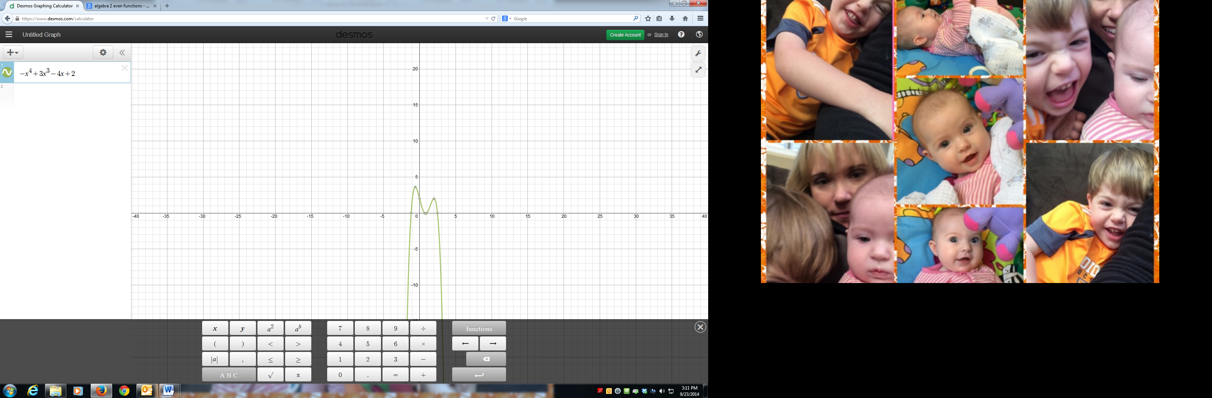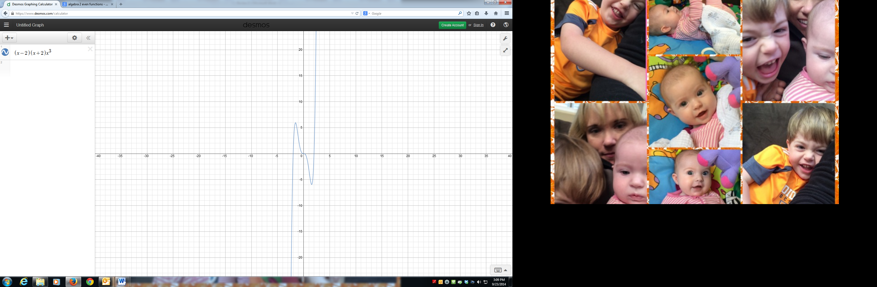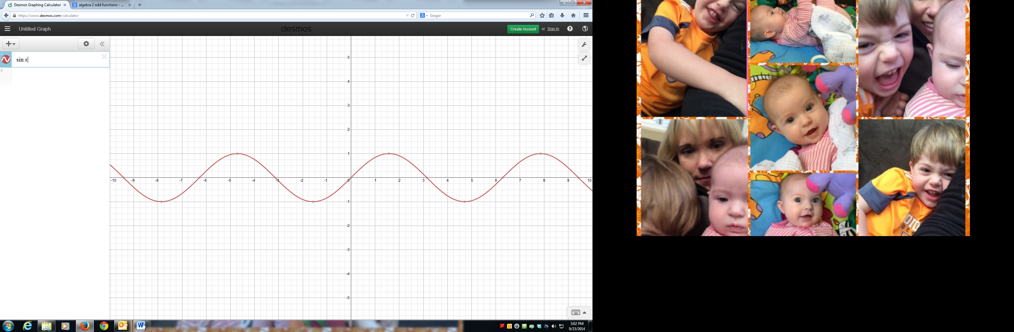8. 9. 10.

11. 12. 13.

Graph each function. Identify the key characteristics.

14. 15.



Domain: Domain:

Range: Range:

x-int: x-int:

y-int: y-int:

Increase: Increase:

Decrease: Decrease:

End Behavior: End Behavior:

Symmetry: Symmetry:

Even/Odd: Even/Odd: